## SRI VENKATAESWARA COLLEGE OF ENGINEERING AND TECHNOLOGY (AUTONOMOUS)

R.V.S Nagar, Chittoor – 517 127. (A.P)

(Approved by AICTE, New Delhi, Affiliated to JNTU,Anantapur) (Accredited by NBA, New Delhi & NAAC A+, Bangalore)

(An ISO 9001:2000 Certified Institution) 2023-2024



## INTERNSHIP REPORT

A report submitted in partial fulfilment of the requirements for the Award of Degree of

BACHELOR OF TECHNOLOGY

IN

COMPUTER SCIENCE & ENGINEERING

MALLAVARAPU VANDANA

Reg No. 21781A0582

JAVA DEVELOPMENT

Under Supervision Of SLASH MARK

(Duration: 13/05/2024 to 06/07/2024)

**SRI VENKATAESWARA COLLEGE OF ENGINEERING AND TECHNOLOGY**

**(AUTONOMOUS)**

R.V.S Nagar, Chittoor – 517 127. (A.P)

(Approved by AICTE, New Delhi, Affiliated to JNTUA, Anantapur) (Accredited by NBA, New Delhi & NAAC A+, Bangalore)

(An ISO 9001:2000 Certified Institution)

2023-2024



CERTIFICATE

This is to certify that the “Internship report” submitted by MALLAVARAPU VANDANA (Regd.No.:21781A0582) is work done by him and submitted during 2024-2025.Academic year, in partial fulfilment of the requirements for the award of the Degree of **BACHELOR OF TECHNOLOGY in COMPUTER SCIENCE & ENGINEERING** , at SLASH MARK.

#### Dr.D.Dhayalan Dr.P.Jyotheeswari

**Internship coordinator Head Of The Department**

## CERTIFICATE



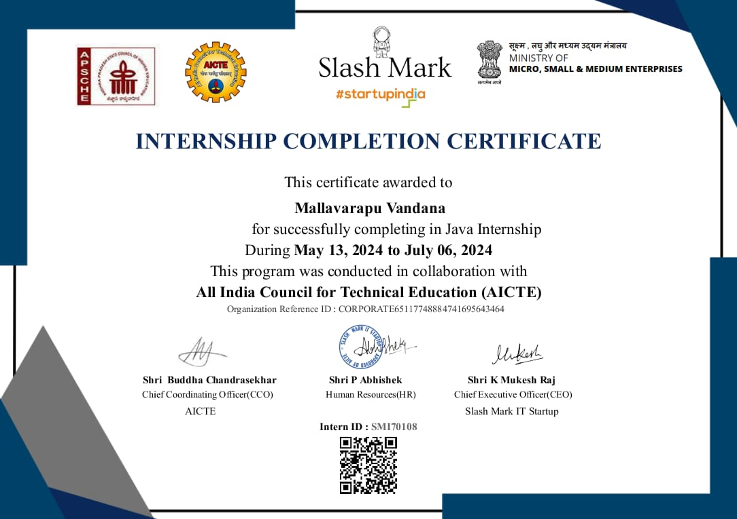

**ACKNOWLEDGEMENT**

* A Grateful thanks to **Dr.R.VENKATASWAMY** Chairman of Sri Venkateshwara College of Engineering & Technology(Autonomous) for providing education in their esteemed institution. I wish to record my deep sense of gratitude and profound thanks to our beloved Vice Chairman, Sri R.V. Srinivas for his valuable support throughout the course.
  + I express our sincere thanks to **Dr.M.MOHAN BABU**, our beloved principal for his encouragement and suggestion during the course of study.
    - With the deep sense of gratefulness, I acknowledge **Dr.P.Jyotheeswari**

Head of the Department, Computer Science Engineering , for giving us inspiring guidance in undertaking internship.

* + I express our sincere thanks to the internship coordinator **Dr.D.Dhayalan**, for his keen interest, stimulating guidance, constant encouragement with our work during all stages, to bring this report into fruition.
  + I wish to convey my gratitude and sincere thanks to all members for their support and cooperation rendered for successful submission of report.
  + Finally, I would like to express my sincere thanks to all teaching, non- teaching faculty members, our parents, and friends and for all those who have supported us to complete the internship successfully.

Name: Mallavarapu Vandana

Roll.No: 21781A3240

**ABSTRACT**

This report summarizes the key experiences and learnings from the Java Internship Course undertaken at SLASH MARK . The course aimed to equip participants with essential Java programming skills and practical knowledge applicable in real-world software development environments. Throughout the internship, participants engaged in hands-on projects, collaborative coding sessions, and code reviews, which enhanced their understanding of core Java concepts, object-oriented programming, and software design patterns.

The curriculum included modules on Java fundamentals, data structures, and algorithms, as well as advanced topics such as multithreading, JavaFX, and RESTful web services. Additionally, participants were introduced to version control systems like Git, which facilitated effective collaboration and project management.

Through problem-solving exercises and team-based projects, interns developed critical thinking and communication skills essential for a successful career in technology. The course culminated in the development of a comprehensive project that incorporated learned skills, reinforcing the practical application of Java in addressing real-world challenges. This experience has not only solidified participants' technical competencies but also prepared them for future endeavors in software development.

## ORGANIZATIONAL PROFILE

Slash Mark is a dynamic software development company located in [Insert Location], specializing in innovative technology solutions that drive business success. Founded in [Year], Slash Mark has established itself as a leader in the tech industry, focusing on custom software development, web and mobile applications, and IT consulting services. The company's mission is to empower businesses through technology by delivering high-quality, tailor-made software solutions that enhance efficiency and improve customer experiences. With a vision to be a globally recognized leader in software innovation, Slash Mark is committed to leveraging cutting-edge technologies to solve complex business challenges. The company values innovation, collaboration, quality, and integrity, ensuring that it stays ahead of industry trends while fostering a supportive work culture. The Java Internship Course at Slash Mark is designed to provide students and recent graduates with hands-on experience in Java programming and software development. Participants work alongside experienced developers on real projects, gaining practical skills and insights into the software development lifecycle. Through this program, interns enhance their technical skills while cultivating a passion for innovation and a strong work ethic, preparing them for successful careers in technology. Slash Mark has successfully collaborated with various clients across multiple industries, including finance, healthcare, and e-commerce, delivering tailored solutions that meet specific business needs.

# INDEX

|  |  |  |
| --- | --- | --- |
| **S.NO** | **NAME OF THE TITLE** | **PAGE NO** |
| 1 | Introduction | **1-3** |
| 2 | INTRODUCTION | **4** |
| 3 | MODULAR DESCRIPTION | **5-6** |
| 4 | SYSTEM REQUIREMENTS   * 1. Software requirements   2. Hardware Requirements   3. System Analysis   4. System Design | **7-9** |
| 5 | SYSTEM TESTING AND IMPLEMENTATION   * 1. System Testing   2. System Implementation | **10-17** |
| 6 | SOFTWARE ARCHITECTURE   * 1. Java   2. JDBC   3. MY SQL | **18-25** |
| 7 | DATA FLOW DIAGRAMS | **26-29** |
| 8 | DATABASE DESIGN | **30-33** |
| 9 | SOURCE CODE | **34** |
| 10 | SCREEN LAYOUTS | **39** |
| 11. | Project | 40 |
| 12. | Output | 47 |
| 13. | Conclusion | **48** |

## Learning Objectives /Internship Objectives

Internships are generally thought of to be reserved for college students looking to gain experience in a particular field. However, a wide array of people can benefit from Training Internships in order to receive real world experience and develop their skills.

An objective for this position should emphasize the skills you already possess in the area and your interest in learning more

Internships are utilized in a number of different career fields, including architecture, engineering, healthcare, economics, advertising and many more.

Some internship is used to allow individuals to perform scientific research while others are specifically designed to allow people to gain first-hand experience working.

Utilizing internships is a great way to build your resume and develop skills that can be emphasized in your resume for future jobs. When you are applying for a Training Internship, make sure to highlight any special skills or talents that can make you stand apart from the rest of the applicants so that you have an improvedchance of landing the position.

## . 1. INTRODUCTION

The introduction of employee performance refers to the initial phase of evaluating and managing an employee's job-related achievements, behavior, and contributions within an organization. It typically encompasses the establishment of performance expectations, setting objectives, and outlining the framework for ongoing performance assessment and feedback.

Employee performance refers to the act of recognizing and appreciating an employee's efforts, achievements, and contributions within the workplace.

Employee performance is defined as how well a person executes their job duties and responsibilities. Many companies assess their employees' performance on an annual or quarterly basis to define certain areas that need improvement and to encourage further success in areas that are meeting or exceeding expectations.

The Employee Management System (EMS) is a comprehensive software solution designed to streamline the administration of employee-related tasks within organizations. This system enhances efficiency by automating key processes such as recruitment, onboarding, attendance tracking, and performance management. By centralizing employee data, EMS provides HR professionals with easy access to vital information, facilitating informed decision-making. Furthermore, it promotes transparency and accountability through robust reporting features. As businesses increasingly seek to optimize their human resource operations, the EMS plays a crucial role in fostering a productive workplace. This report explores the system's functionalities, benefits, and implementation strategies.

## 2. MODULAR DESCRIPTION

The Java program for managing employee performance evaluation can be modularized into the following main modules:

#### Database Connection Module:

* Responsible for establishing a connection to the MySQL database.
* Initializes the Connection and Statement objects for database interaction.

#### User Authentication Module:

* Handles user authentication for both managers and employees.
* Validates usernames and passwords by querying the database tables (MANAGER_LOGIN and EMPLOYEE_LOGIN).

#### Manager Menu Module:

* Provides functionality for managers after successful login.
* Displays a menu with options for adding employee details, adding evaluation details, updating evaluation details, deleting employee records, deleting evaluation records, and logging out.
* Invokes corresponding methods based on manager's choices.

#### Employee Menu Module:

* Provides functionality for employees after successful login.
* Displays a menu with an option to view their performance details.
* Invokes the displayEmployeePerformance() method when the employee chooses to view performance details.
* Allows employees to log out.

#### Employee Details update Module:

* Includes methods for adding employee details (addEmployee()), which collects employee information and inserts it into the Employee table in the database.
* Supports deleting employee records (deleteEmployee()) based on the provided employee ID.

#### Evaluation Details update Module:

* Contains methods for adding evaluation details (addEvaluation()), which collects evaluation information and inserts it into the Evaluation table in the database.
* Provides the ability to update evaluation details (updateEvaluation()) based on the provided evaluation ID.
* Allows for the deletion of evaluation records (deleteEvaluation()) based on the provided evaluation ID.

#### Employee data Display Module:

* Retrieves and displays a list of employee performance details by joining data from the Employee and Evaluation tables.
* Part of the displayEmployeePerformance() method.

#### Exit Module:

* Closes the database connection gracefully (exit() method) when the program exits.
* Exits the program after closing the connection.

These modular components divide the program's functionality into clear, organized sections, making it easier to understand, maintain, and extend. Each module focuses on a specific aspect of employee performance evaluation, enhancing the program's readability and maintainability.

#### SYSTEM REQUIREMENTS

* 1. **Software Requirements**

Frontend: Html, Css, javaScript, jsp Back End:java servlet

Database:MySQLmysqconnect-java- 8.0.13.jar

Middleware: JDBC(java database connectivity)

Server: Apache Tomcat

Development Environment: eclipse IDE for java and web applications

Version control :git/GitHub

* 1. Hardware Requirements Processor : Intelcorei3_2348M CPU Speed : 2.30 MHZ

Memory : 300

# System Analysis

#### Introduction to System Analysis

System analysis is a process of gathering interpreting facts, diagnosing problems, and using facts to improve the system. The objective of the system analysis is to understand the important facts of current system by studying it in detail. To accomplish this objective the following have to be done.

* + - Learn the details of the system as well as procedures currently in practice.
    - Develop insight into future demands of the organization on its growth; hike in Competition, evolving new financial structures, introduction of new technology, and changes in the customer needs.
    - Documentation details of the current system for discussion and review by others.
    - Evaluate effectiveness and efficiency of the current system and procedure taking into account the impact of anticipating future demands.
    - Recommend any revisions and enhancements to the current system, indicating how they are justified. If appropriate, an entire new system may be purposed.
    - Document the new system features at a level of details that allows others to understand its components and manage the new system developed.

#### 4.4 System Design

The design of a system produces the details that state how a system meet the requirements identified during system analysis. System specialists often refer to this stage as logical design, in contrast to the process of developing program software, which is referred to as physical design.

Data Flow Diagrams have been used in the design of the system. Data Flow Diagram is a graphical tool used to describe and analyze the movement of data. The transformation of data from input to output, through processes may be described logically using these Data Flow Diagrams.

The DFD shown to the user must represent only the major functions being performed by the system. This is called Top Level DFD. If this process is complex enough, it can be broken further into different levels. This process can be continued till the process is simple. This is called the leveling of DFD‟s.

1. **SYSTEM TESTING AND IMPLEMENTATION**

#### System Testing

Theoretically, a new designed system should have all the pieces in working order, but in reality, each piece works independently. Now is the time to put all pieces into one system and test it to determine whether it meets the user‟s requirements. The purpose of the system is to consider all the likely variations to which it will be subjected and then push the system to its limits. It is tedious but necessary step in system development. One needs to be familiar with the following basic terms.

* + - **Unit Testing:** Unit Testing is testing changes made in an existing or a new program.
    - **Sequential or Series Testing:** Sequential or Series Testing is checking the logic of one or more programs in the candidate system, where the output of one program will affect the processing done by another program.
    - **System Testing:** System Testing is executing a program to check logic changes made in it and with the intention of finding errors making the program fail.
    - **Acceptance Testing:** Acceptance Testing is running the system with live data by the actual user of the system.

Testing is vital to the success of the system. System testing makes a logical assumption that if all the parts of the system are correct, the goal will be successfully achieved. In adequate testing or no-testing leads to errors that may not appear until months later. Another reason for system testing is its utility as a user-oriented vehicle before implementation. The best program and the user have communication barriers due to different backgrounds. The system tester (designer, programmer, or user) who has developed some computer mastery can bridge this barrier.

#### Unit Testing:

This focuses on the smallest unit of software design. The module using the details design description as a guide; important control paths are tested to uncover errors within the boundary of the module.

#### Unit test consideration:

The module interface id tested to ensure that information properly flows into and out of the program unit under test. The local data structures are examined to ensure that the data stored temporarily maintains it integrity during all steps in an algorithm execution. Boundary conditions are tested to ensure that the module operates properly at boundaries established to limit or restrict processing. The test of data flow across a module interface is required before any other test. If data do not enter and exit properly, all other tests are moot.

#### Unit Procedure:

* + Unit test is normally considered adjunct to the coding style.
  + After source level code has been developed, reviewed and verified for correct syntax, unit test case design begins. Each test case should be coupled with a set of expected results.
  + Normally, a driver is a “main program” that accepts test case data, passes such data to the module to be tested and prints the relevant results. Stubs serve to replace modules that are subroutines called by the module to be tested. A Stub or „dummy stub program‟ uses the subroutine module‟s interface to do minimal data manipulation and returns.
  + Unit testing is simplified when a module with high cohesion is designed. When a module addresses only one function, the number of test cases is reduced and errors can be more easily predicted and uncovered.

#### Integration Testing:

Integration is a systematic technique for constructing the program structure, while at the same time conducting tests to uncover errors associated with interfacing. The objective is to make

unit-tested modules and build a program structure that has been dictated by design. Incremental integration is the program that is the program that is constructed and tested in small segments where errors are easier to isolate and correct.

#### Top down Integration:

Top-down integration is an incremental approach to the construction of program structure. Modules are integrated by moving downward through the control hierarchy, beginning with the main control module. Module subroutine to the main control module is incorporated into the structure either in a depth-first manner is engaged for this system. Breadth-first incorporates all modules directly subroutine at each level, moving across the structure horizontally.

The integration process is performed in a series of five steps:

1. The main control module is used as a test driver and stubs are substituted for all modules directly subroutine to the main control module.
2. Depending on the integration approach selected (depth or breadth first) subroutine stub are replaced one at a time with actual modules.
3. Tests are conducted as each module is integrated.
4. On the completion of each set of test, another stub is replaced with the real module.
5. Registration testing is conducted to ensure that new errors have not been introduced.

#### Validation testing:

At the end of integration testing, the system is completely assembled as a package with interfacing errors corrected after which a final series of software tests namely validation testing begins. Validation succeeds when the software functions in a manner that can be reasonably expected by the user.

#### Criteria:

Software validation is achieved through black box tests that demonstrates conformity with requirements.

#### (iV) System Testing:

System testing is actually a series of different tests whose primary purpose is to fully exercise the computer-based system. Although each test has a different purpose, all work should verify that all system elements have been properly integrated and perform allocated functions. Being the most important test, the performance test is covered briefly below:

#### Performance Testing:

For real-time systems, software that provides required function but does not conform to performance requirement is unacceptable. Performance testing is designed to test the run-time performance of software within the context of an integrated system. Performance testing occurs throughout all steps in the testing process. Even at the unit level, the performance of an individual module may be accessed as tests are conducted. However, it is not until all system elements are fully integrated that the true performance of a system can be ascertained.

#### Debugging:

Debugging is not testing not occurs as a consequence of testing, that is when a test case uncovers an error, debugging is the process that results in the removal of the error.

#### Normally three categories for debugging approaches are proposed:

* 1. Brute force
  2. Back-tracking
  3. Cause-elimination

#### Brute force:

This is the most common and least efficient method for isolating the cost of a software error. Brute-force debugging method is usually applied when all else fails. Using a “let the computer finding the error” philosophy, memory-dumps are taken, runtime traces are invoked and the program is loaded with WRITE (in this case message box) statements. In the information that is produced, a clue is found leading to the cause of the error.

#### Back-tracking:

This is fairly common debugging approach that can be used successfully in small programs. Beginning at the site where a symptom has been uncovered, the source code is traced backwards (manually) until the site of the cost is found.

#### Cause-Elimination:

This approach is manifested by induction/deduction and introduces the concept of

„binary partition‟. A „cause hypothesis‟ is devised and the error related data are used to prove or disprove the hypothesis. Alternatively, a list of all possible causes is developed, and tests are conducted to eliminate each. If initial tests indicate that a particular cause hypothesis shows promise, that data are refined in an attempt to isolate the path.

Each of the debugging approaches can be supplemented with debugging tools. A wide variety of debugging compilers, dynamic debugging aids (tracers), automatic test case generators, memory dumps and cross- reference maps can be applied. However, tools are not a substitute for careful evaluation, based on a complete software design document and clear source code.

#### SYSTEM IMPLEMENTATION

After proper testing and validation, the question arises whether the system can be implemented or not. Implementation includes all those activities that take place to convert from the old system to the new. The new system may be totally new, replacing an existing module or automated system, or it may be major modification to an existing system. In either case proper implementation is essential to provide a reliable to provide a reliable system to meet organization requirements.

All planing has now, be completed and the transformation to a fully operational system can commence. The first job will be writing, debugging documenting of all computer programs and their integration into a total system. The master and transaction files are decided, and this general processing of the system is established. Programming is complete when the programs conformed to the detailed specification.

When the system is ready for implementation, emphasis switches to communicate with the finance department staff. Open discussion with the staff is important form the beginning of the project. Staff can be expected to the concerned about the effect of the automation on their jobs and the fear of redundancy or loss of status must be allayed immediately. During the implementation phase it is important that all staff concerned be apprised of the objectives of overall operation of the system. They will need shinning on how computerization will change their duties and need to understand how their role relates to the system as a whole. An organization-training program is advisable; this can include demonstrations, newsletters, seminars etc.

The department should allocate a member of staff, who understands the system and the equipment, and should be made responsible for the smooth operation of the system. An administrator should coordinate the users to the system.

Users should be informed about new aspects of the system that will, affect them. The features of the system explained with the adequate documentation. New services such as security, on-line application from the back-ups must be advertise on the staff when the time is ripe.

Existing documents such as employee loan details should be entered into the new system. Since these files are very large, conversion of these may continue long after the system based on current files has been implemented.

Hence we need to assign responsibility for each activity.

The system may come into full operation via number of possible routes. Complete change over at one point time is conceptually the most tidy. But this approach requires careful planning and coordination, particularly during the changeover. A phased approach, possible implementing the system of the section relating to one operation or procedure first and processing to more novel or complex subsystems in the fullness of time. These likely to be less traumatic. A phased approach gives the staff time to adjust to the new system. But depends on being able to split the system, without reliance on it. Thus approach is sensible when the consequences of failure are disastrous, but will require extra staff time.

## SOFTWARE ARCHITECTURE

The following diagram illustrates the links between various components involved in this system:

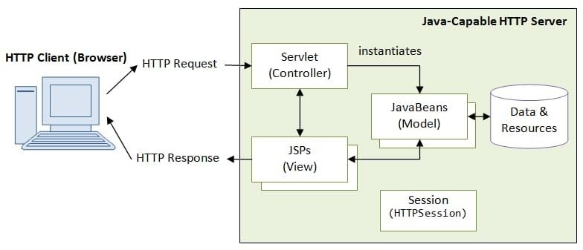

In the following sections the salient features of each of their components are discussed:

* Java
* JDBC
* MY SQL

**EMPLOYEE PERFORMANCE SYSTEM**

**DATABASE LAYER**

**MYSQL DATABASE**

**EMPLOYEE MODULE**

**MANAGER MODULE**

This architectural representation provides an overview of the key components and their interactions within the Employee Performance System. You can use this as a starting point to create a more detailed and visually appealing software architecture diagram using a diagramming tool.

## JAVA

#### WHAT IS JAVA?

Java ha two things: a programming language and a platform.Java is a high-level programming language that is all of the following

|  |  |
| --- | --- |
| Simple | Architecture-neutral |
| Object-oriented | Portable |
| Distributed | High-performance |
| Interpreted | multithreaded |
| Robust | Dynamic |

Secure

Java is also unusual in that each Java program is both compiled and interpreted. With a compile, you translate a Java program into an intermediate language called Java bytecodes the platform- independent code instruction is passed and run on the computer.

Compilation happens just once; interpretation occurs each time the program is executed. The figure illustrates how this works.

Java Program

Compilers

My Program

Interpreter

You can think of Java byte codes as the machine code instructions for the Java Virtual Machine (Java VM). Every Java interpreter, whether it‟s a Java development tool or a Web browser that can run Java applets, is an implementation of the Java VM. The Java VM can also be implemented in hardware.

Java byte codes help make “write once, run anywhere” possible. You can compile your Java program into byte codes on my platform that has a Java compiler. The byte codes can then be run any implementation of the Java VM. For example, the same Java program can run Windows NT, Solaris, and Macintosh.

## JAVA PLATFORM

A platform is the hardware of software environment in which a program runs.

The Java platform differs from most other platforms in that it‟s a software only platform that runs on the top of other, hardware-based platform. Most other platforms are described as a combination of hardware and operating system.

The Java platform has two components:

* + 1. The Java Virtual Machine (Java VM)
    2. The Java Application Programming Interface (Java API)

You have already been introduced to the Java VM. It‟s the base for the Java platform and is ported onto various hardware-based platforms.

The Java API is a large collection of ready-made software components that provide many useful capabilities, such as graphical user interface (GUI) widgets.

The Java API is grouped into libraries (package) of related components. The next sections, what can Java do? Highlights each area of functionally provided by the package in the Java API.

The following figure depicts a Java program, such as an application or applet, that‟s running on the Java platform. A special kind of application known as a server serves and supports clients on a network. Examples of the servers include Web Servers, proxy servers, and mail servers, print servers, and boot servers. Another specialized program is a Servlet. Servlets are similar to applets in that they are runtime extensions of the application. Instead of working in browsers, though, Servlets run with in Java Web Servers, configuring of tailoring the server.

How does the Java API support all of these kinds of programs? With packages of software components, that provides a wide range of functionality. The API is the API included in every full implementation of the platform

The core API gives you the following features:

1. The Essentials: Objects, Strings, threads, numbers, input and output, data structures, system properties, date and time, and so on.
2. Applets: The set of conventions used by Java applets.
3. Networking URL‟s TCP and UDP sockets and IP addresses.
4. Internationalization: Help for writing programs that can be localized for users.

Worldwide programs can automatically adept to specific locates and be displayed in the appropriate language.

#### JAVA PROGRAM

* + Java API
  + Java Virtual Machine
  + Java Program
  + Hard Ware

API and Virtual Machine insulates the Java program from hardware dependencies. As a platform-independent environment, Java can be a bit slower than native code. However, smart compilers, well-tuned interpreters, and Just- in-time-byte-code compilers can bring Java‟s performance close to the native code without threatening portability.

#### WHAT CAN JAVA DO?

However, Java is not just for writing cut, entertaining applets for the World Wide Web (WWW). Java is a general purpose, high-level programming language and a powerful software platform. Using the fineries Java API, you can write many types of programs.

The most common types of program are probably applets and application, where a Java application is a standalone program that runs directly on the Java platform.

#### Security:

Both low-level and high-level, including electronic signatures, public/private key management, accesses control, and certificate.

#### JAVA DATABASE CONNECTIVITY (JDBC) JDBC AND ODBC IN JAVA:

Most popular and widely accepted database connectivity called Open Database Connectivity (ODBC) is used to access the relational databases. It offers the ability to connect to almost all the databases on almost all platforms. Java applications can also use this ODBC to communicate with a database. Then we need JDBC why? There are several reasons:

* ODBC API was completely written in C language and it makes an extensive use of pointers. Calls from Java to native C code have a number of drawbacks in the security, implementation, robustness and automatic portability of applications.
* ODBC is hard to learn. It mixes simple and advanced features together, and it has complex options even for simple queries.
* ODBC drivers must be installed on client‟s machine.

#### Architecture of JDBC:

JDBC Architecture contains three layers:

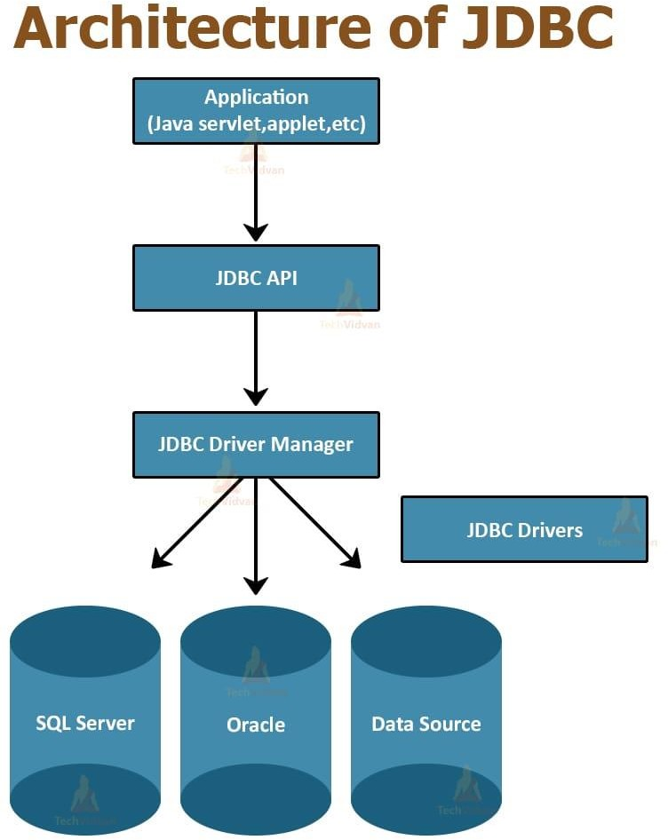

* + 1. Application Layer: Java program wants to get a connection to a database. It needs the information from the database to display on the screen or to modify the existing data or to insert the data into the table.
    2. Driver Manager: The layer is the backbone of the JDBC architecture. When it receives a connection-request form.
    3. The JDBC Application Layer: It tries to find the appropriate driver by iterating through all the available drivers, which are currently registered with Device Manager. After finding out the right driver, it connects the application to appropriate database.
    4. JDBC Driver layers: This layer accepts the SQL calls from the application and converts them into native calls to the database and vice- versa. A JDBC Driver is responsible for ensuring that an application has consistent and uniform m access to any database.

When a request received by the application, the JDBC driver passes the request to the ODBC driver, the ODBC driver communicates with the database, sends the request, and gets the results. The results will be passed to the JDBC driver and in turn to the application. So, the JDBC driver has no knowledge about the actual database, it knows how to pass the application request o the ODBC and get the results from the ODBC.

The JDBC and ODBC interact with each other, how? The reason is both the

JDBC API and ODBC are built on an interface called “Call Level Interface” (CLI). Because of this reason, the JDBC driver translates the request to an ODBC call. The ODBC then converts the request again and presents it to the database. The results of the request are then fed back through the same channel in reverse.

#### JDBC DRIVERS:

JDBC Driver is a software component that enables java application to interact with the database. There are 4 types of JDBC drivers:

1. JDBC-ODBC bridge driver
2. Native-API driver (partially java driver)
3. Network Protocol driver (fully java driver)
4. Thin driver (fully java driver)

#### JDBC-ODBC bridge driver:

The JDBC-ODBC bridge driver uses ODBC driver to connect to the database. The JDBC- ODBC bridge driver converts JDBC method calls into the ODBC function calls. This is now discouraged because of thin driver.

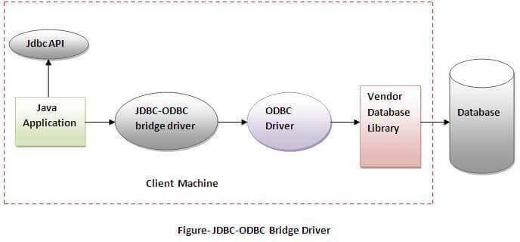

Oracle does not support the JDBC-ODBC Bridge from Java 8. Oracle recommends that you use JDBC drivers provided by the vendor of your database instead of the JDBC-ODBC Bridge.

Advantages:

* Easy to use. o Can be easily connected to any database.

Disadvantages:

* Performance degraded because JDBC method call is converted into the ODBC function calls.
* The ODBC driver needs to be installed on the client machine.

#### Native-API driver(partially java driver):

The Native API driver uses the client-side libraries of the database. The driver converts JDBC method calls into native calls of the database API. It is not writtenentirely in java.

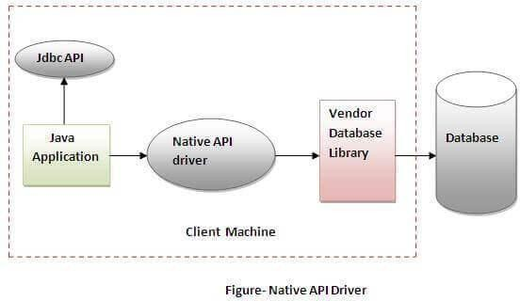

Advantage:

* + performance upgraded than JDBC-ODBC bridge driver.

Disadvantage:

* + The Native driver needs to be installed on the each client machine.
  + The Vendor client library needs to be installed on client machine.

#### Network Protocol driver:

The Network Protocol driver uses middleware (application server) that converts JDBC calls directly or indirectly into the vendor-specific database protocol. It is fully written in java.

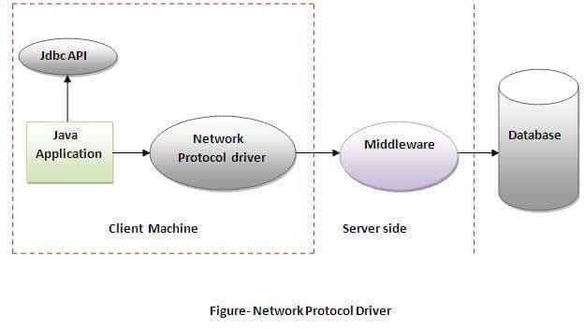

Advantage:

* + No client side library is required because of application server that can perform many tasks like auditing, load balancing, logging etc.

Disadvantages:

* + Network support is required on client machine. o Requires database-specific coding to be done in the middle tier.
  + Maintenance of Network Protocol driver becomes costly because it requires database- specific coding to be done in the middle tier.

#### Thin driver:

The thin driver converts JDBC calls directly into the vendor-specific database protocol. That is why it is known as thin driver. It is fully written in Java language.

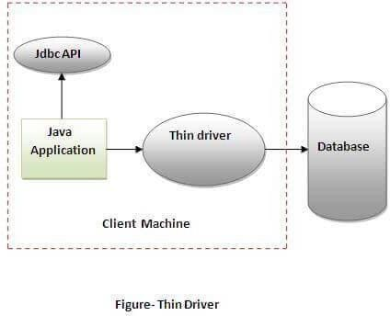

Advantage:

* + Better performance than all other drivers.
  + No software is required at client side or server side.

Disadvantage:

o Drivers depend on the Database

When a request received by the application, the JDBC driver passes the request to the ODBC driver, the ODBC driver communicates with the database, sends the request, and gets the results. The results will be passed to the JDBC driver and in turn to the application. So, the JDBC driver has no knowledge about the actual database, it knows how to pass the application request o the ODBC and get the results from the ODBC.

The JDBC and ODBC interact with each other, how? The reason is both the

JDBC API and ODBC are built on an interface called “Call Level Interface” (CLI). Because of this reason, the JDBC driver translates the request to an ODBC call. The ODBC then converts the request again and presents it to the database. The results of the request are then fed back through the same channel in reverse.

#### Why we using JDBC?

Java applications that interact with databases:

Database Connectivity: JDBC provides a standardized and consistent way to establish connections to relational databases from Java applications. This connectivity is crucial for applications that need to store, retrieve, or manipulate data stored in databases.

Database Independence**:** JDBC abstracts the underlying database-specific details, allowing developers to write database code in a database-agnostic manner. This means you can write Java code that can work with different relational database management systems (DBMS) without making significant changes to the codebase.

Data Retrieval and Manipulation**:** JDBC allows you to execute SQL queries and updates against the database. This enables your Java application to retrieve data from the database, insert, update, or delete records, and perform other database operations.

Parameterized Queries: JDBC supports prepared statements (via Prepared Statement), which are precompiled SQL queries with placeholders for parameters. This feature enhances security and performance by preventing SQL injection attacks and optimizing query execution.

Transaction Management**:** JDBC provides APIs for managing database transactions. You can use JDBC to start, commit, or roll back transactions, ensuring data integrity and consistency.

Error Handling: JDBC includes a mechanism for handling database-related exceptions (e.g., SQL Exception) that may occur during database operations. This allows you to gracefully handle errors and provide appropriate feedback to users.

Scalability: JDBC can be used in both small-scale and large-scale applications. It scales well to handle a wide range of database-related tasks, from simple queries to complex database interactions.

Integration with Java Ecosystem**:** JDBC integrates seamlessly with other Java technologies and frameworks. For example, it can be used in Java EE (Enterprise Edition) applications, Spring Framework applications, and more.

Legacy Systems**:** In many cases, organizations have legacy systems that rely on relational databases. JDBC provides a means to integrate and interact with these existing database systems while still leveraging Java's capabilities.

Flexibility: Developers have fine-grained control over the database interactions through JDBC. This flexibility allows you to optimize database access for your specific application needs.

#### Structured Query Language (SQL)

SQL (Pronounced Sequel) is the programming language that defines and manipulates the database. SQL databases are relational databases; this means simply the data is store in a set of simple relations. A database can have one or more table. You can define and manipulate data in a table with SQL commands. You use the data definition language (DDL) commands to creating and altering databases and tables.

You can update, delete or retrieve data in a table with data manipulation commands (DML). DML commands include commands to alter and fetch data.

The most common SQL commands include commands is the SELECT command, which allows you to retrieve data from the database.

In addition to SQL commands, the oracle server has a procedural language called PL/SQL. PL/SQL enables the programmer to program SQL statement. It allows you to control the flow of a SQL program, to use variables, and to write error-handling procedures.

#### What are MySQL's technical requirements?

These are MySQL's technical requirements:

* Manageability and Usability
* Flexible architecture
* High accessibility and replication
* Drivers
* MySQL Enterprise Manager
* JSON Compatibility
* High Availability and Replication
* Controlling storage and security
* Transactions and OLTP
* High performance that is easy to use and manage

#### FEATURES OF SQL:

SQL (Structured Query Language) is a domain-specific language used for managing and manipulating relational databases. It is the standard language for interacting with relational database management systems (RDBMS) like MySQL, PostgreSQL, Oracle, SQL Server, and others. SQL has several key features that make it a powerful tool for working with databases:

* Data Querying:SQL allows users to retrieve data from a database by writing queries. These queries can range from simple SELECT statements to complex joins and sub queries, making it easy to filter, sort, and extract specific data sets.
* Data Manipulation: SQL provides commands for adding, updating, and deleting data within a database. These commands are essential for maintaining the integrity and accuracy of data.
* Data Definition: SQL includes commands for defining the structure of a database, such as creating tables, defining columns and their data types, and specifying constraints (e.g., primary keys, foreign keys).
* Data Control: SQL offers data control features that enable administrators to manage access to data. This includes creating user accounts, granting or revoking privileges, and setting up roles and permissions.
* Transaction Control:SQL supports transactions, which are sequences of one or more SQL statements that are executed as a single unit of work.

This ensures data consistency and integrity, allowing users to commit or roll back changes.

* Data Integrity: SQL enforces data integrity rules through constraints, such as primary keys, unique constraints, foreign keys, and check constraints. These rules ensure that data remains accurate and consistent.
* Indexing: SQL allows you to create indexes on columns to improve query performance. Indexes speed up data retrieval by providing a quick way to look up records based on indexed columns.
* Joins: SQL supports various types of joins (e.g., INNER JOIN, LEFT JOIN, RIGHT JOIN, FULL JOIN) to combine data from multiple tables based on specified relationships, enabling complex data analysis.
* Aggregation: SQL provides aggregate functions (e.g., SUM, AVG, COUNT, MAX, MIN) that allow users to perform calculations on sets of data, making it possible to generate summary information from large datasets.
* Sub queries: SQL allows you to nest queries within other queries, known as sub queries. This feature is valuable for retrieving data that depends on the results of another query.
* Views: SQL supports the creation of views, which are virtual tables based on the results of a query. Views simplify complex queries, enhance data security, and provide a way to present data in a more user-friendly format.
* Stored Procedures and Functions: SQL allows you to create reusable code blocks called stored procedures and functions. These are useful for encapsulating complex logic within the database, promoting code reusability and maintainability.
* Triggers: Triggers in SQL are special types of stored procedures that are automatically executed in response to predefined events, such as data modifications (INSERT, UPDATE, DELETE). Triggers are useful for enforcing business rules and auditing

changes.

#### WHY WE USING SQL COMMANDS?

SQL commands are used for various purposes in database management and data manipulation. They serve several essential functions and provide numerous benefits, which is why they are widely used:

* Data Retrieval: SQL SELECT statements allow users to retrieve data from a database. This is one of the fundamental uses of SQL, enabling users to extract specific information from large datasets.
* Data Modification: SQL provides commands for adding, updating, and deleting data in a database. These commands are crucial for maintaining the accuracy and integrity of data.
* Data Definition: SQL commands like CREATE TABLE, ALTER TABLE, and DROP TABLE are used to define and manage the structure of a database, including tables, columns, and constraints.
* Data Control: SQL commands like GRANT and REVOKE are used to manage access to data. Database administrators can grant or revoke privileges to control who can view or modify data.
* Data Aggregation: SQL includes aggregate functions (e.g., SUM, AVG, COUNT) that allow users to perform calculations on sets of data, which is essential for generating summary reports and statistics.
* Data Filtering: SQL WHERE clauses and conditions help users filter and narrow down results, allowing for precise data retrieval.
* Data Sorting: SQL commands can sort query results in ascending or descending order, making it easier to analyze data and present it in a meaningful way.
* Data Joins: SQL supports various types of joins (e.g., INNER JOIN, LEFT JOIN) to combine data from multiple tables based on specified relationships, facilitating complex data analysis.
* Data Validation: SQL constraints (e.g., primary keys, foreign keys, check constraints) ensure data integrity by enforcing rules and preventing invalid data entries.
* Data Indexing: SQL allows the creation of indexes on columns to improve query performance, enabling faster data retrieval.
* Data Transformation: SQL commands can be used to transform data, such as converting data types, performing calculations, and formatting output.
* Data Security: SQL commands can be used to define and enforce security policies, restrict unauthorized access, and protect sensitive data.
* Automation: SQL commands can be scripted and automated, making it easier to perform repetitive database tasks and batch processing.
* Reporting: SQL queries can be used to extract data for generating reports, charts, and dashboards, aiding decision-making processes.
* Scalability: SQL databases are highly scalable, allowing them to handle large volumes of data and grow as an organization's data needs increase.
* Consistency and Reliability: SQL databases provide transaction management and data consistency, ensuring that data remains accurate and reliable even in multi-user environments.
* Compatibility: SQL is a standardized language, and most relational database management systems (RDBMS) adhere to the SQL standard, providing a consistent interface across different database platforms.

Overall, SQL commands are a fundamental tool for managing, querying, and manipulating data within relational databases. They enable efficient data storage, retrieval, and analysis, making them essential for organizations and individuals working with structured data.

## Data Flow Diagrams

#### Definition:

A data flow diagram is a graphical technique that depicts information flow and the transforms that applied as data move from input to output. The Data flow diagram used to represent a system or software at any level of abstraction. In fact DFDs may be portioned into levels.

A level of DFD, also called a context model, represents the entire software elements as a single bubble with input and output by arrow. A level of DFD is portioned into several bubbles with inter connecting arrows. Each of the process represented at level one is sub function of the over all depicted in the context model**.**

#### The DFD Notations:

External Entity Hardware person and other program.

Information of the system to be modeled.

Process

Data Item(s): Arrowhead indicates the direction of flow



DATA FLOW

Store

Stored Information that is used by the s/w DIAGRAM FOR OVERALL

SYSTEM:

USER ENTRY

EMPLOYEE MENU:

EMPLOYEE LOGIN

DISPLAY DETAILS

LOGOUT

MANAGER LOGIN

EMPLOYEE

PERFORMANCE SYSTEM

EMPLOYEE LOGIN

### View Evaluation details

MANAGER MENU:

MANAGER LOGIN

ADD

EMPLOYEE

DELETE EMPLOYEE

ADD

EVALUATION

DELETE

EVALUATION

UPDATE

EVALUATION

EMPLOYEE

EMPLOYEE MAINATAINANCE

## DATABASE DESIGN

Designing an employee performance project using Core Java involves several components, such as creating a database schema, implementing Java classes setting up for database interaction, and managing employee performance data.

Below is a step-by-step guide to help you get started:

# Database Design:

Design the database schema to store employee information and performance data. Here's a basic example of tables you might use:

Manager Login:

CREATE TABLE MANAGER_LOGIN(USERNAME VARCHAR(100), PASSWORD VARCHAR(100));

insert into manager_login values('Anvitha', 'Anvi123');

|  |  |  |
| --- | --- | --- |
| Columns name | datatype | rule |
| username | varchar(100) | Not null |
| password | varchar(100) | Not null |

Employee Login:

CREATE TABLE EMPLOYEE_LOGIN(Id INT PRIMARY KEY AUTO_INCREMENT, USERNAME VARCHAR(255), PASSWORD

VARCHAR(255));

|  |  |  |
| --- | --- | --- |
| Columns name | datatype | rule |
| username | varchar(100) | Not null |
| password | varchar(100) | Not null |

Employee:

CREATE TABLE EMPLOYEE_LOGIN(Id INT PRIMARY KEY

AUTO_INCREMENT, USERNAME VARCHAR(100), PASSWORD VARCHAR(100));

|  |  |  |
| --- | --- | --- |
| **COLUMNS** | **DATATYPE** | **RULE** |
| USERNAME | VARCHAR(100) | NOT NULL |
| PASSWORD | VARCHAR(100) | NOT NULL |

## PROJECT

**SOURCE CODE**

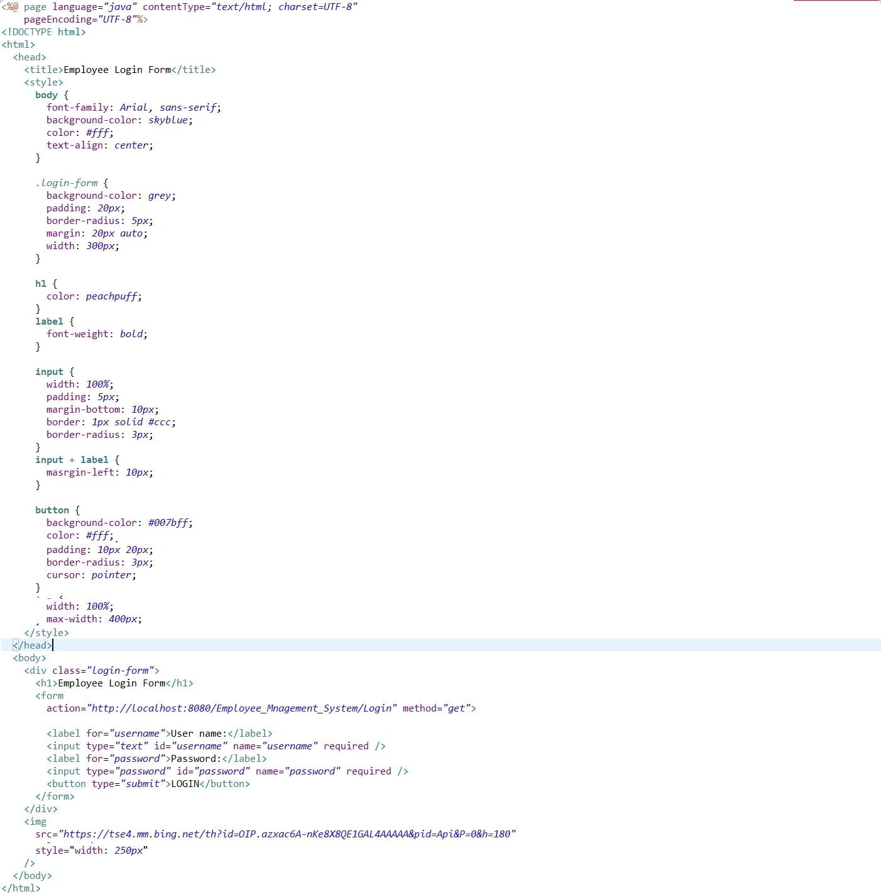

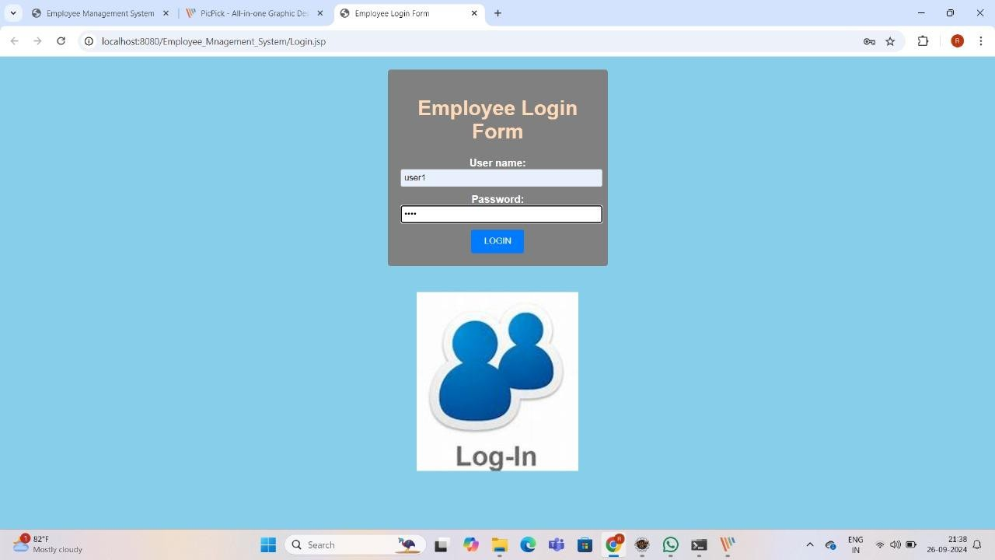

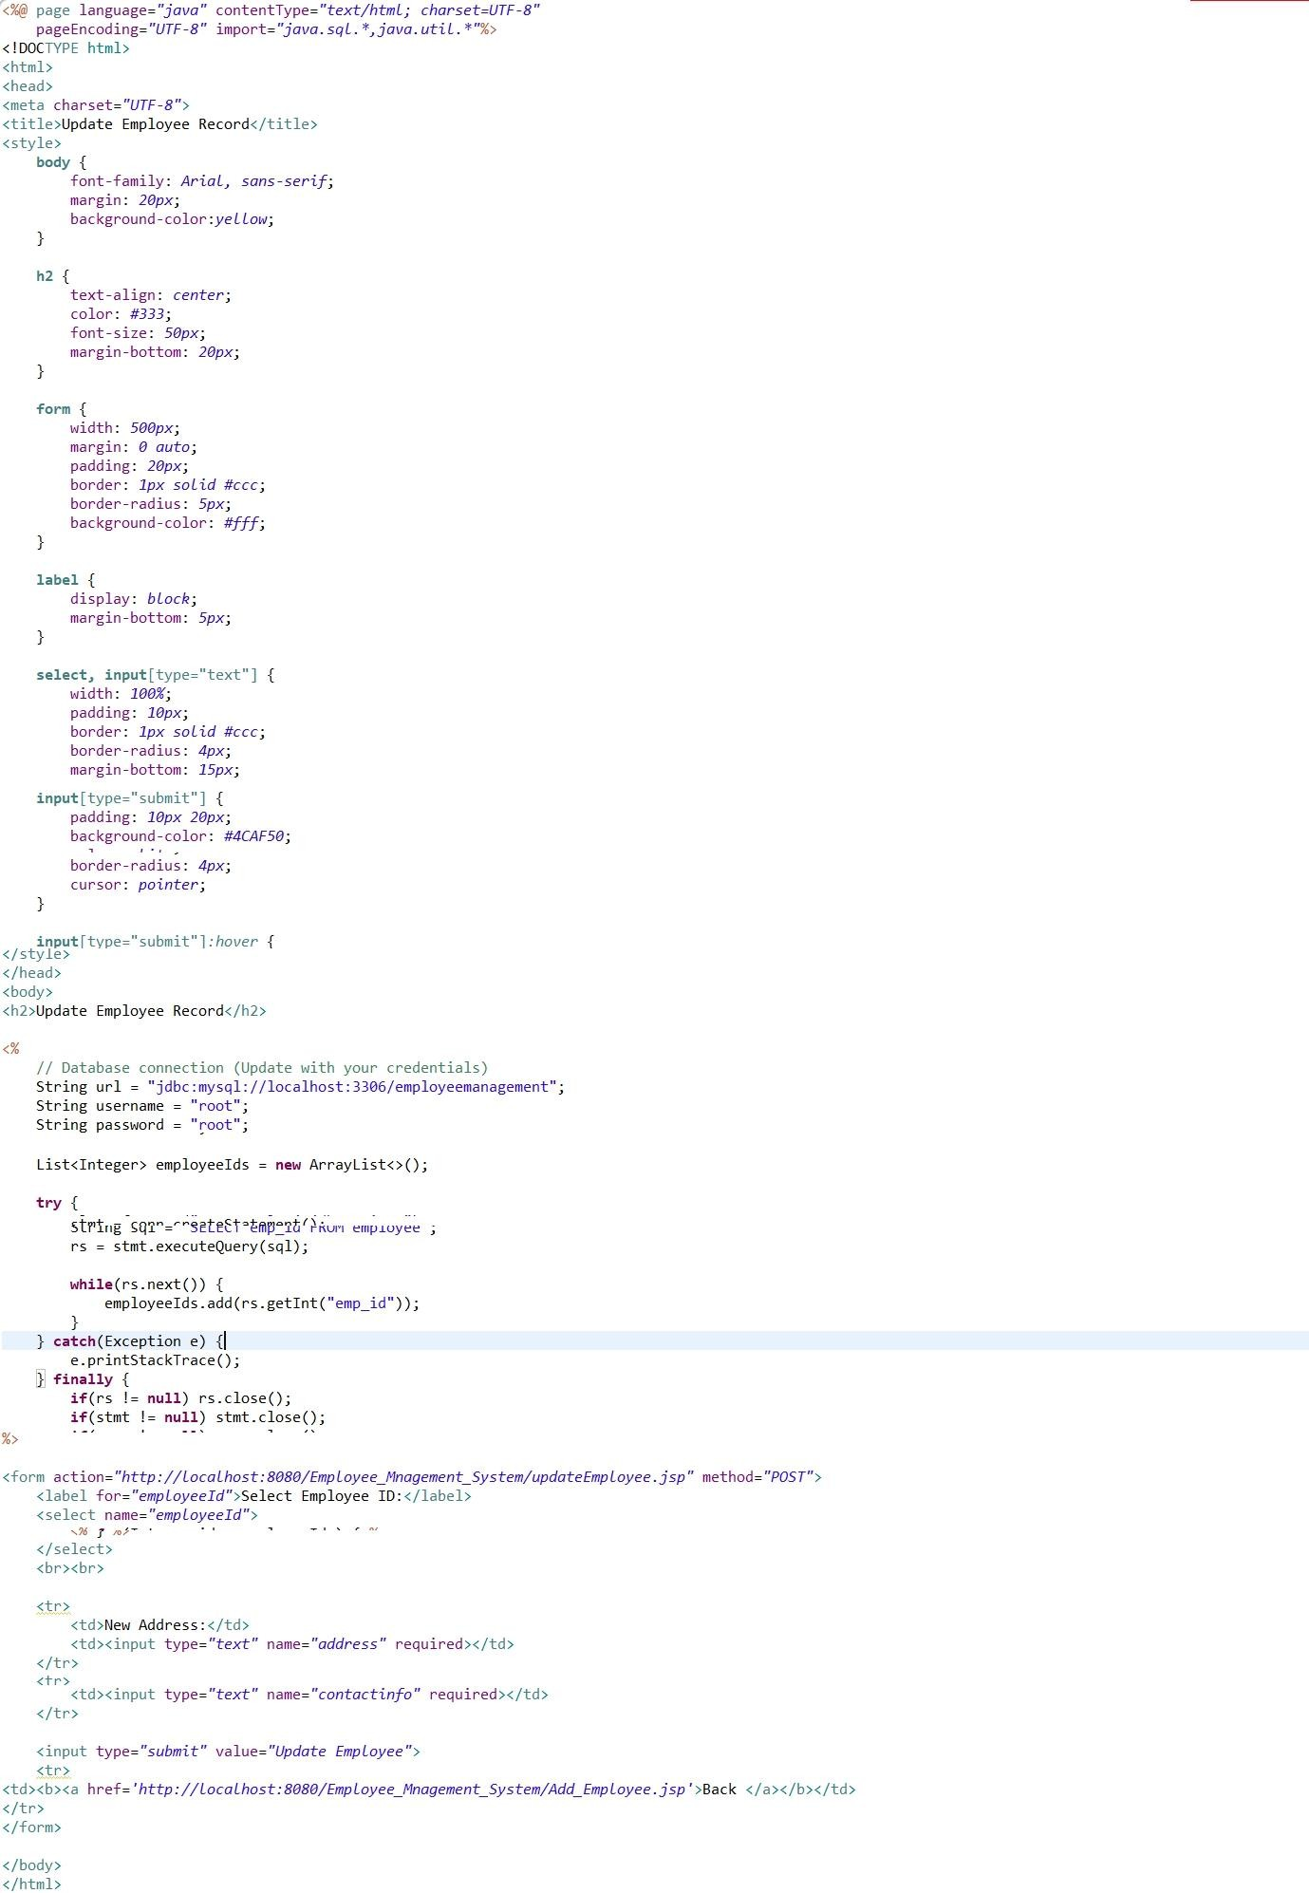

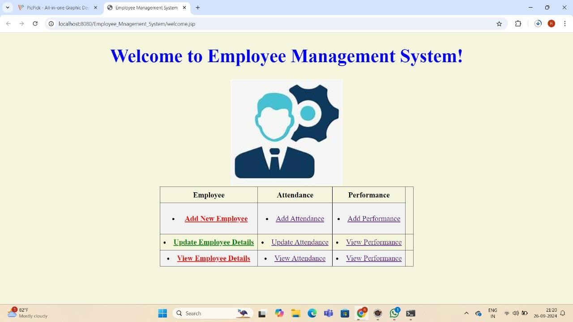

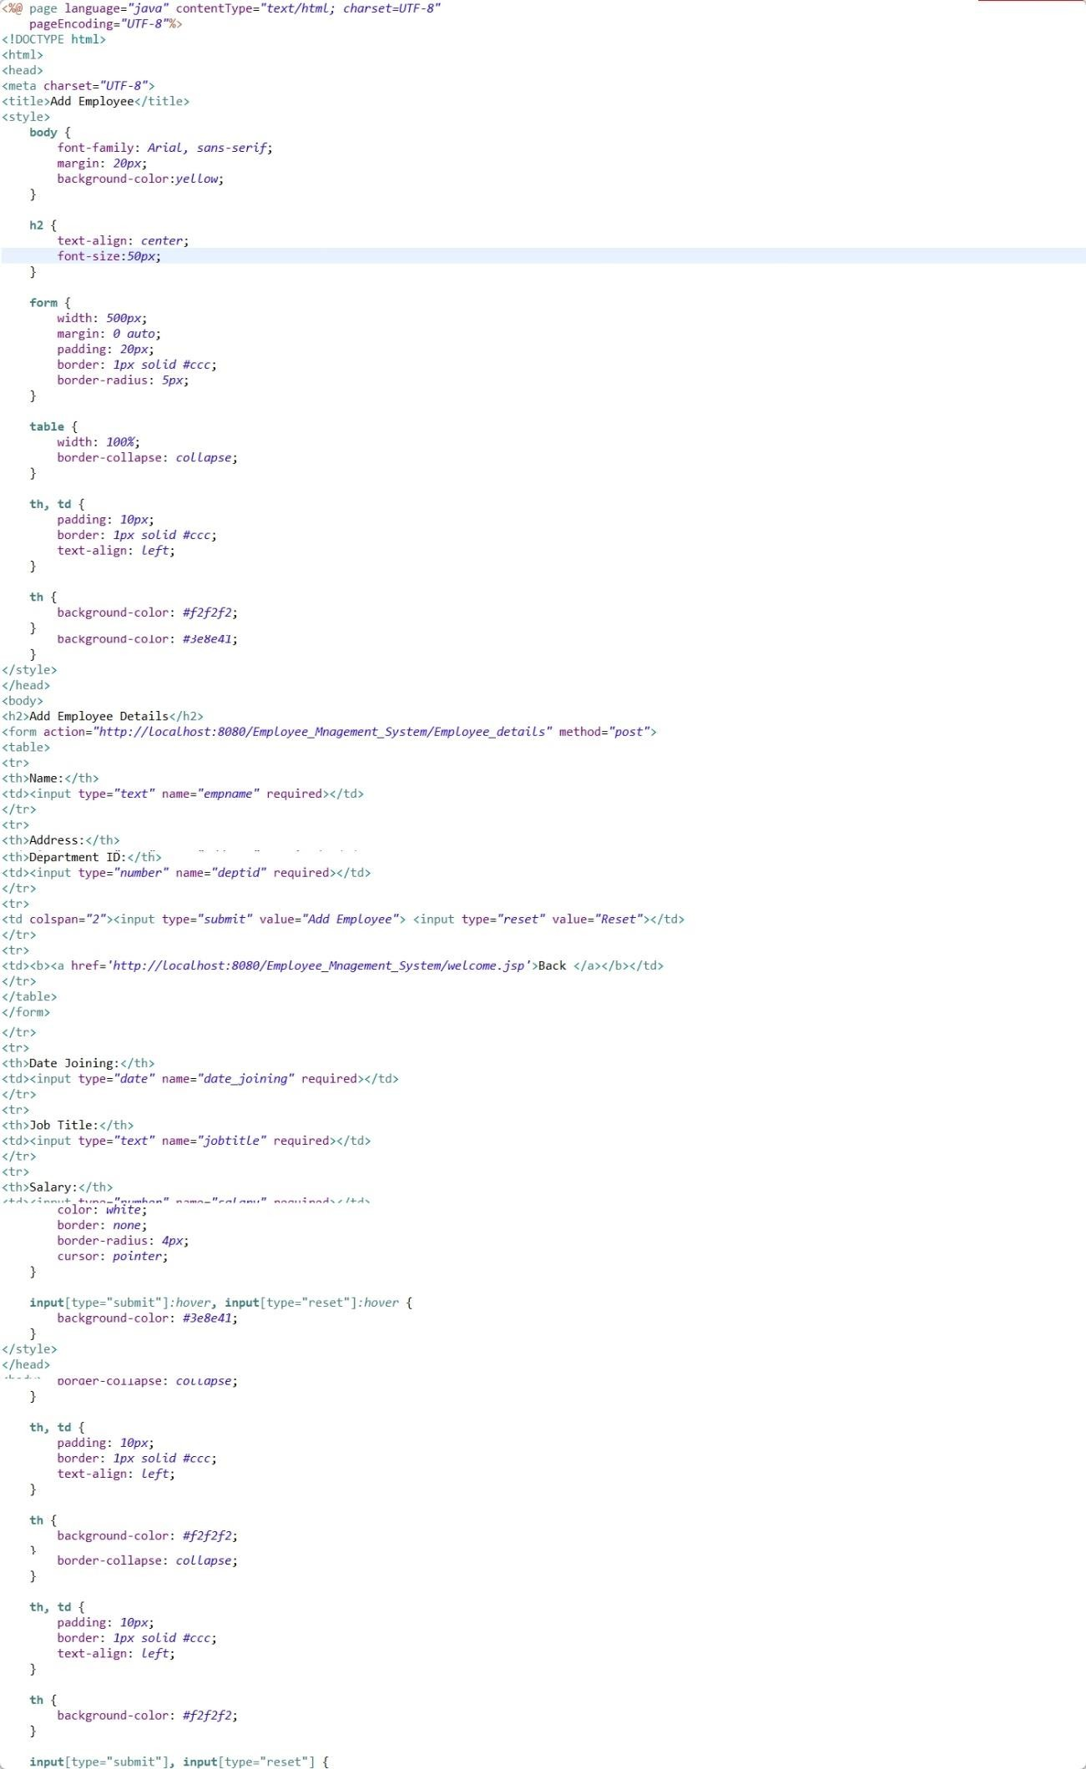

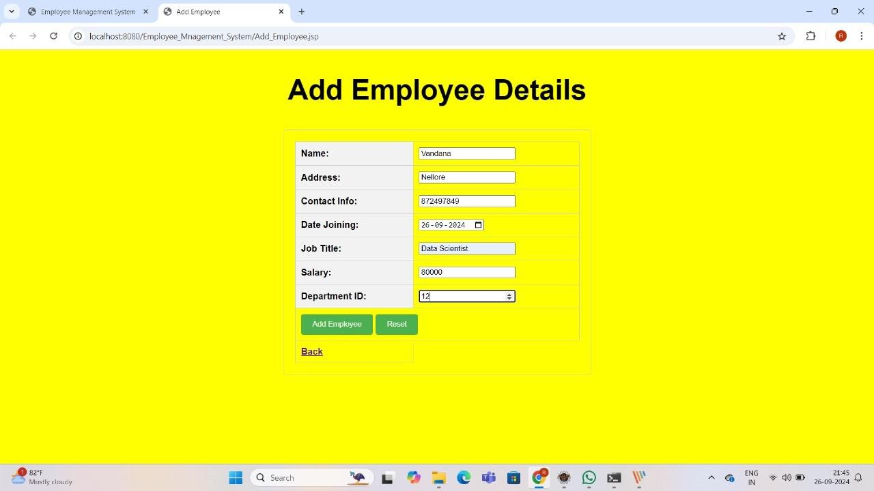

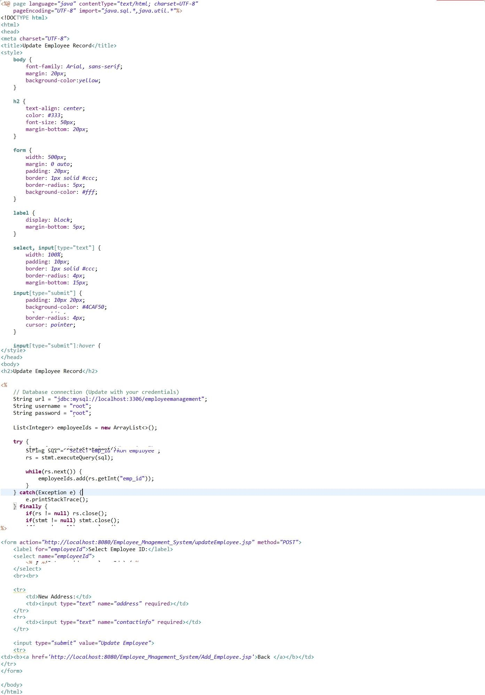

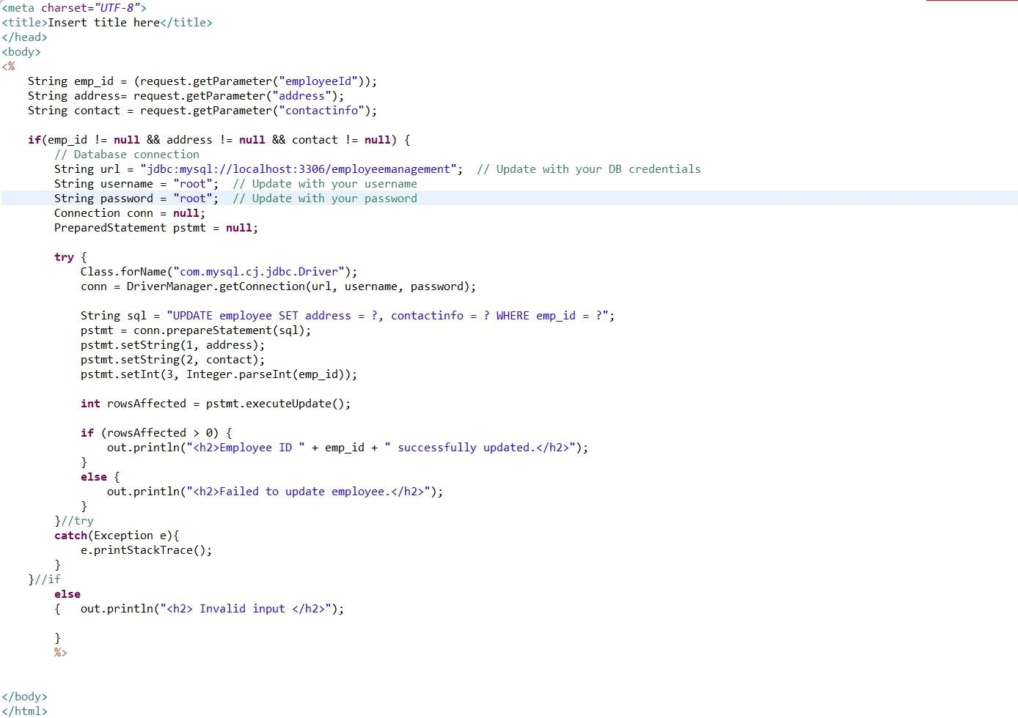

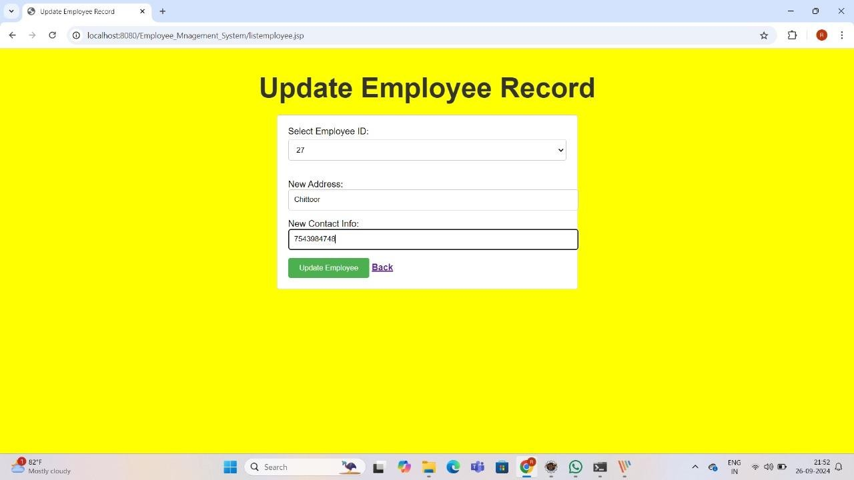

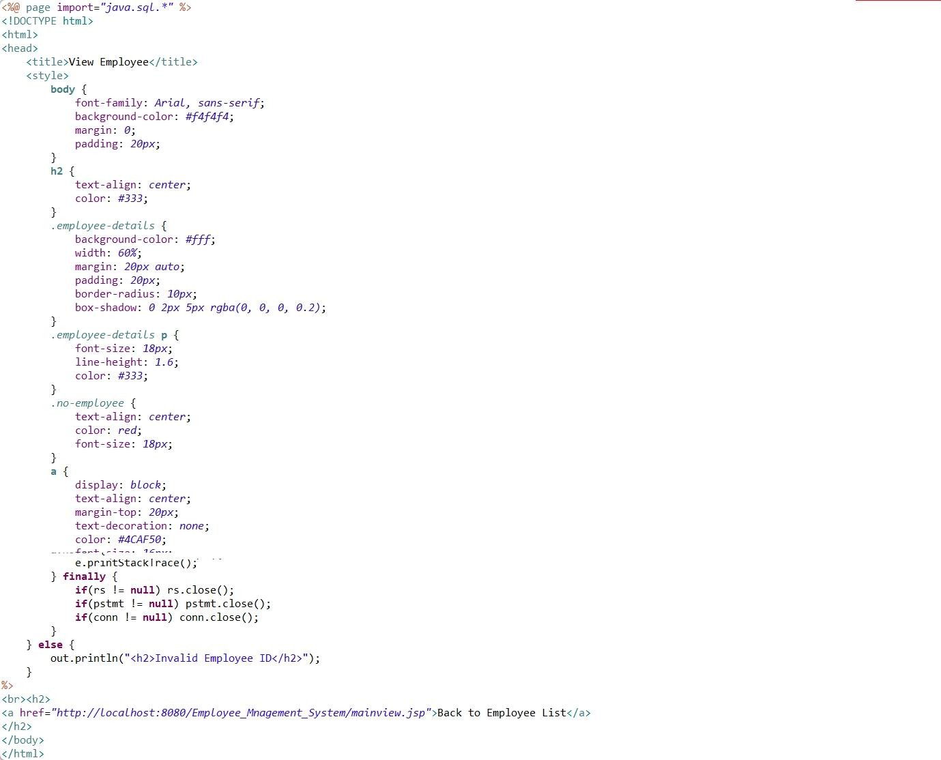

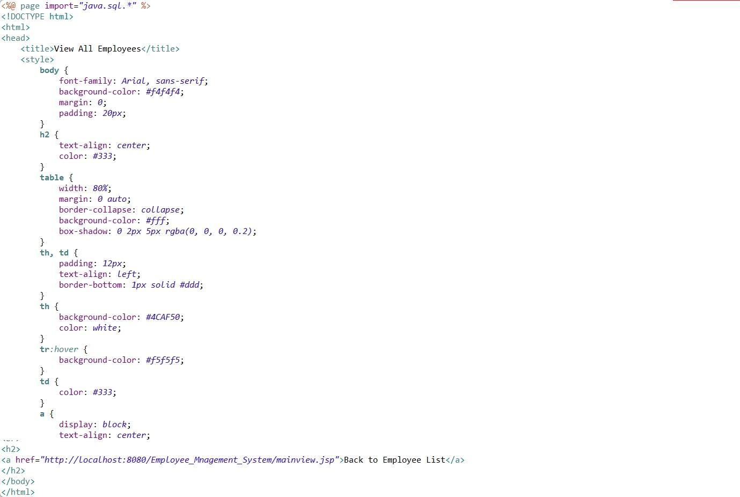

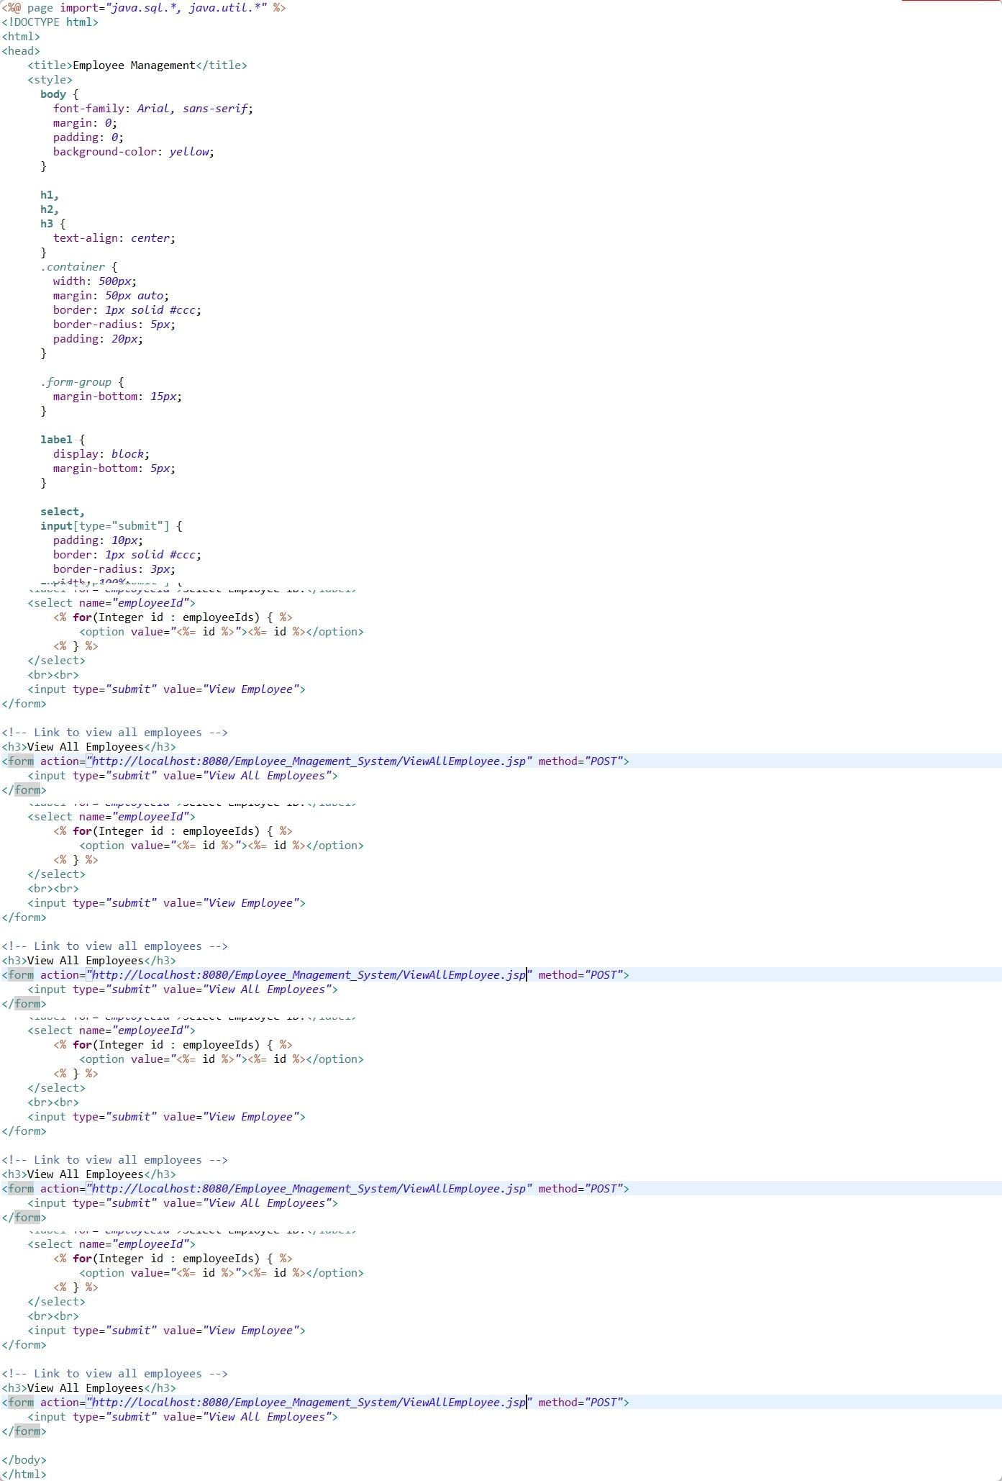

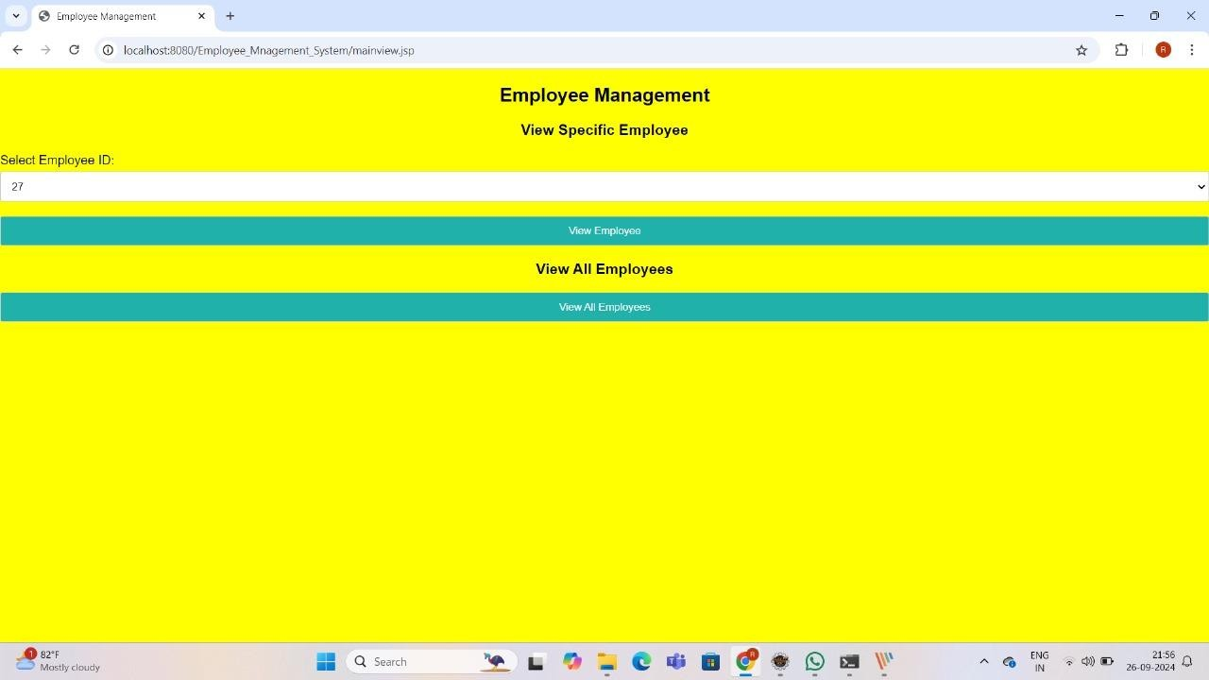

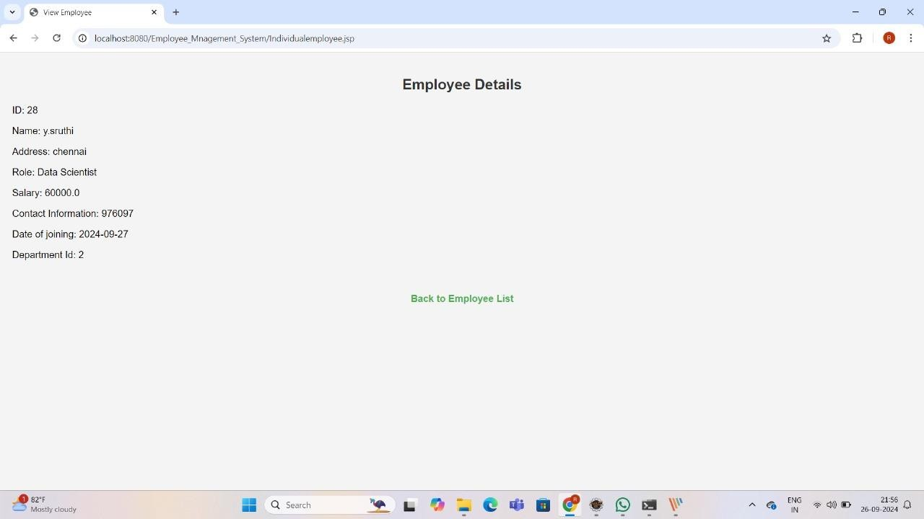

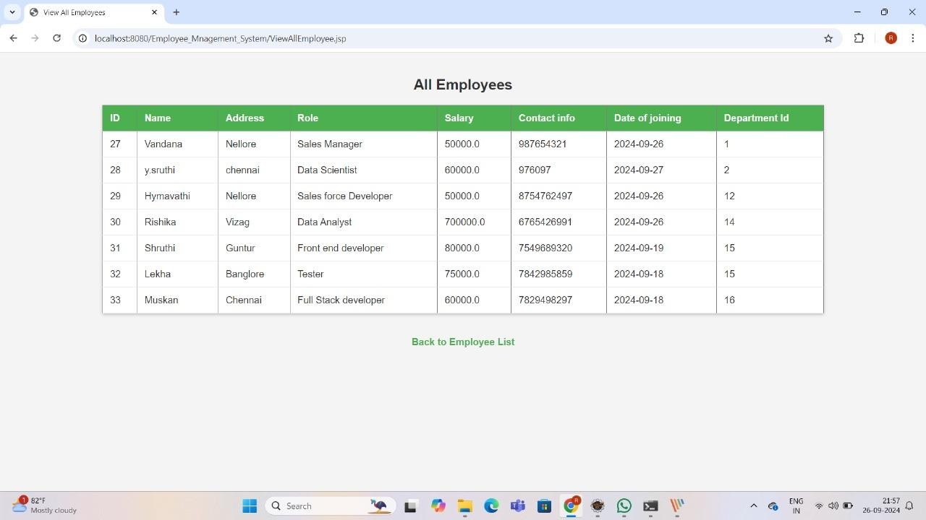

## 11. CONCLUSION

The provided code appears to be the implementation of a basic Employee Performance Evaluation system using Java and a MySQL database.

The project allows for two types of users to log in: managers and employees. Managers can perform actions such as adding employee details, adding evaluation details, updating evaluation details, deleting employees, and deleting evaluation details. Employees, on the other hand, can log in to view their performance details.

The project utilizes a MySQL database to store information about employees, evaluations, manager logins, and employee logins. It establishes a connection to the database and performs SQL operations as needed.

The project provides a simple text-based user interface where users can choose options from a menu.

Basic error handling is implemented with exception handling to handle issues such as database connectivity problems.

#### Improvements:

While this project provides a foundation for managing employee performance, several areas could be enhanced and extended for a more robust and user- friendly system:

* Security Enhancements: Implement robust security measures, including password hashing, encryption, and protection against SQL injection.
* Data Validation: Implement thorough data validation to ensure that inputs are correctly formatted and within acceptable ranges.
* Logging: Add comprehensive logging capabilities to record system activities, errors, and user actions for auditing and troubleshooting.
* User Experience: Improve the user interface with better feedback, error messages, and a more intuitive menu system.
* User Roles and Permissions: Define and implement roles and permissions more comprehensively to control access to specific features.
* Reporting and Visualization: Add reporting and data visualization features to provide insights into employee performance.
* Scalability: Optimize database queries for better performance when handling a larger number of employees and evaluations.
* Testing: Implement rigorous testing, including unit tests and integration tests, to ensure the reliability and correctness of the system.
* Documentation: Document the code and system architecture thoroughly to aid developers and maintainers.

While the provided code serves as a basic Employee Performance Evaluation system, building a complete and production-ready system would involve further development, testing, and security enhancements. The project has the potential to be extended into a valuable tool for managing and analyzing employee performance data.